**Shape Recognition**

**Using**

**Digital Image Processing**

Nirali Trivedi [23626380]

CSC 741 Final Project - Fall 2017

Computer Science Department, College of Staten Island, NY

**Abstract**

This project gives an approach to identify basic geometric shapes in a 2-dimensional image using image processing techniques with the help of Python and OpenCV. The basic shapes included are square, circle, triangle, rectangle and pentagon. The algorithm involves conversion of RGB image to grey scale image and then to black and white image. This is achieved by thresholding concept and contour approximation. Algorithm tested with many images with different shapes and recognizes all.

**Keywords:** geometric; shape; detection; recognition; image processing; python; OpenCV

1. **Introduction**

As we progress and develop, technology changes rapidly and now it is time for automated machines to take over the simple jobs and make them more effective.

The sensors are one of the most significant part of automation. They provide inputs for the controllers to act based upon the inputs received. Cameras are used for Image Processing which finds huge application in the field of automation industry. It captures the images or streams live video and then they are processed as per the needs of the application. Therefore, Image processing and especially blob analysis is often required to check some objects shape depending on its perform and further processing of an object.

The study of shapes is a recurring theme in computer vision. For example, shape is one of the main sources of information that can be used for object recognition. In medical image analysis, geometrical models of anatomical structures play an important role in automatic tissue segmentation. The shape of an organ can also be used to diagnose diseases. In a completely different setting, shape plays an important role in the perception of optical and this can be used to explain how our visual system interprets the ambiguous and incomplete information available in an image.

This project attempts at demonstrating the shape recognition of an object using an algorithm which will be explained in detail. This algorithm is realized with the help of python OpenCV.

1. **Methodology**

A proposed algorithm was suggested for automatically detecting shapes in the images. The algorithm was developed to detect and recognize different shapes in any coloured and non-colored images. This algorithm deal with grey scale images, then any colour image will be converting to grey scale image.

First step in this process is the image enhancement by using histogram equalization, the techniques are well-known for the local contrast enhancement of the images and facilitate the task of image analysis. Enhancement constitutes the first step towards automatic analysis of the images. The second step after performing the equalizations is a Gaussian filtering operation which then applied on resulted image from enhancement to reduce the noise, the Gaussian filter for noise reduction. Bellow figure shows the image in different stages.

**A close up of a sign

Description generated with high confidence** 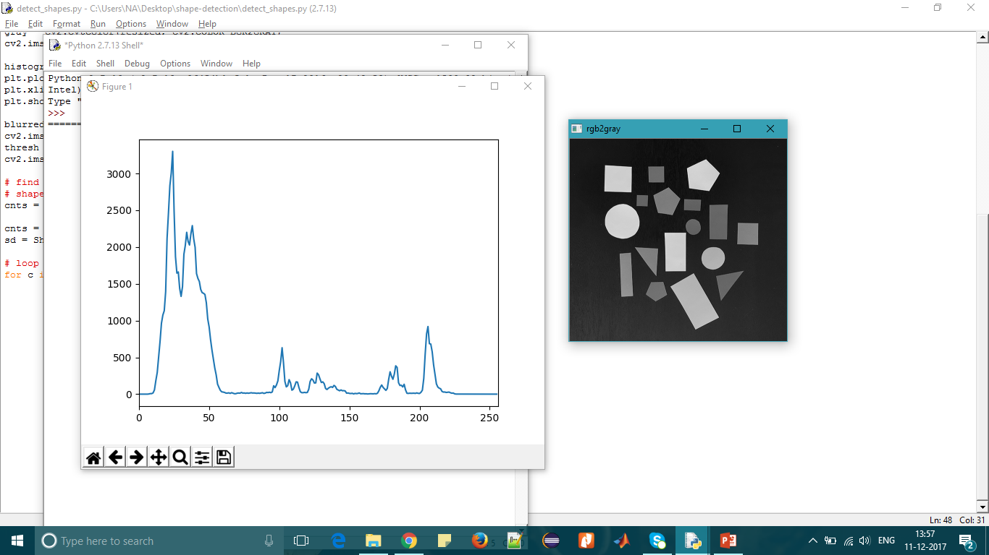

**Fig.1:** **Original Image Fig.2: Grey Scale Image**

A close up of text on a white background

Description generated with high confidence 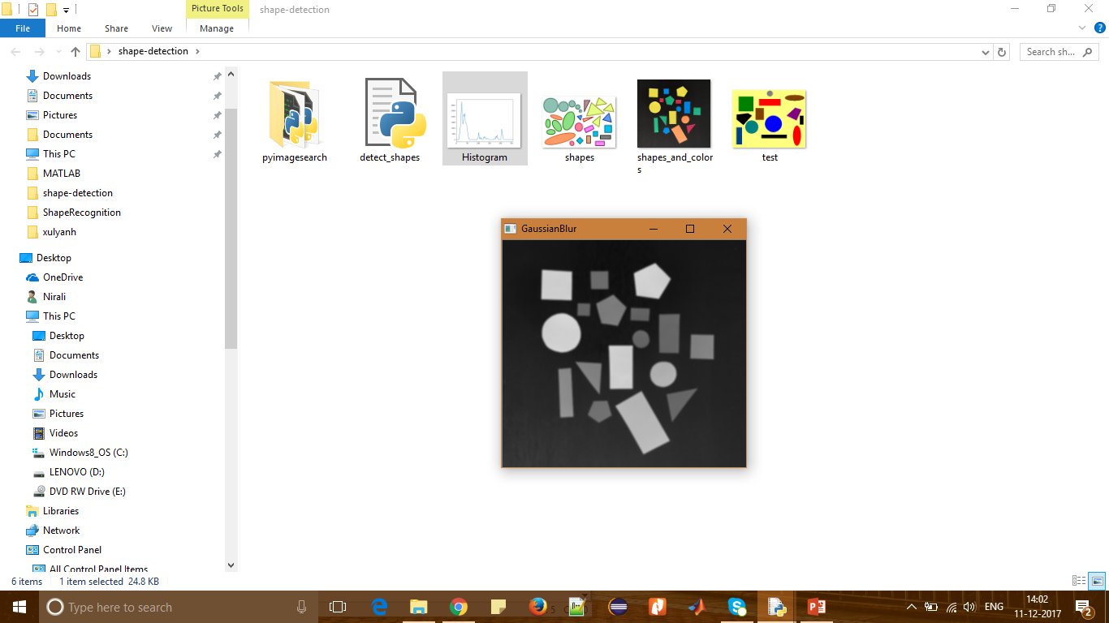

**Fig.3:** **Histogram Fig.4: Gaussian Blur**

After we enhance the image, the image will be converted to binary image by changing each pixel equal or smaller than threshold to white colour with value 1, while the other pixels will change to black colour with value 0. In this case the image background is changed as black colour, while the white pixels represent the objects. Bellow figure represent the same.

A close up of a logo

Description generated with very high confidence 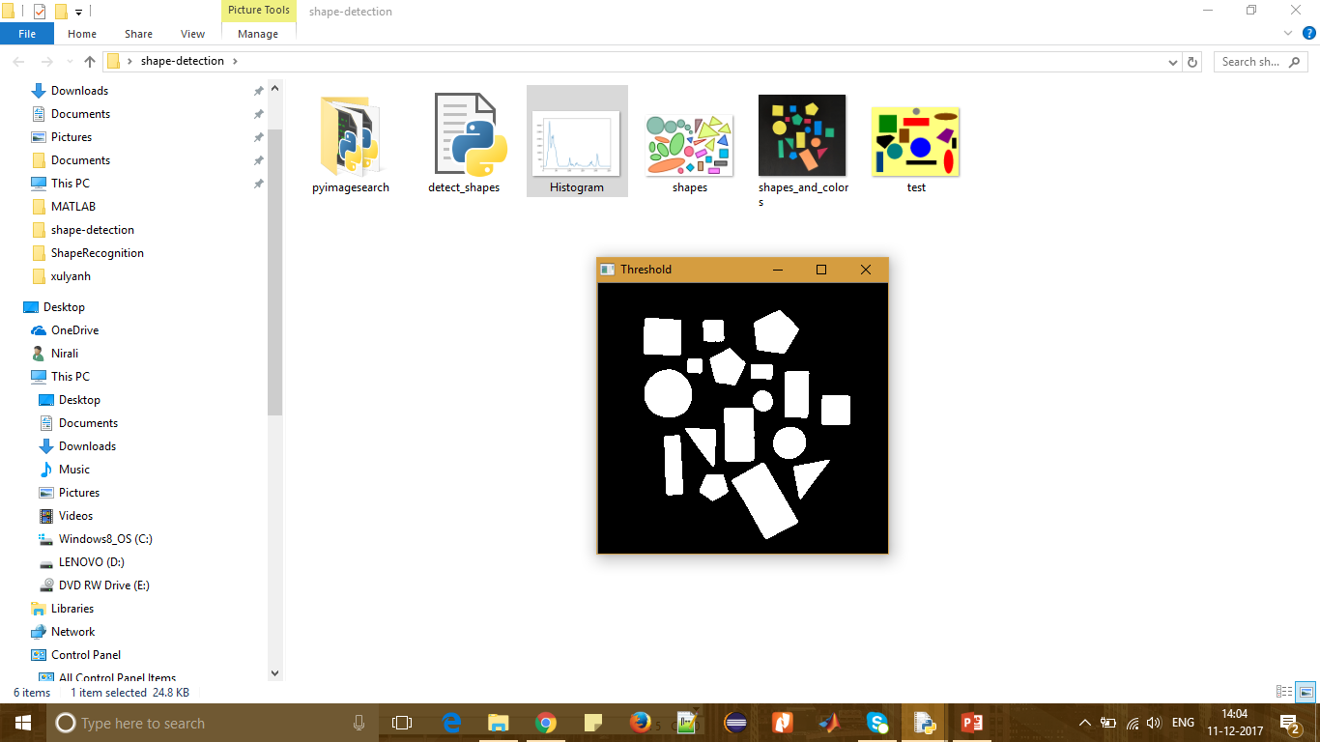

**Fig.5: Edge Detection Fig.6: Thresholding**

To perform shape detection, contour approximation is used. Contour approximation is an algorithm for reducing the number of points in a curve with a reduced set of points. This algorithm is commonly known as the Ramer-Douglas-Peucker algorithm, or simply the split-and-merge algorithm. Contour approximation is predicated on the assumption that a curve can be approximated by a series of short line segments*.* This leads to a resulting approximated curve that consists of a subset of points that were defined by the original curve.

In order to perform contour approximation, first compute the perimeter of the contour, followed by constructing the actual contour approximation. It’s important to understand that a contour consists of a list of **vertices**. Then check the number of entries in this list to determine the shape of an object. For example, if the approximated contour has three vertices*,* then it’s a triangle. If a contour has four vertices*,* then it can be either a square or a rectangle. To determine which, we compute the aspect ratio of the shape, which is simply the width of the contour bounding box divided by the height. If the aspect ratio is ~1.0, then we are examining a square. Otherwise, the shape is a rectangle. If a contour has five vertices*,* we can label it as a pentagon. Otherwise, by process of elimination, we can assume that the shape we are examining is a circle. Lastly, we draw the contours and the labelled shape on our image, followed by displaying results below.

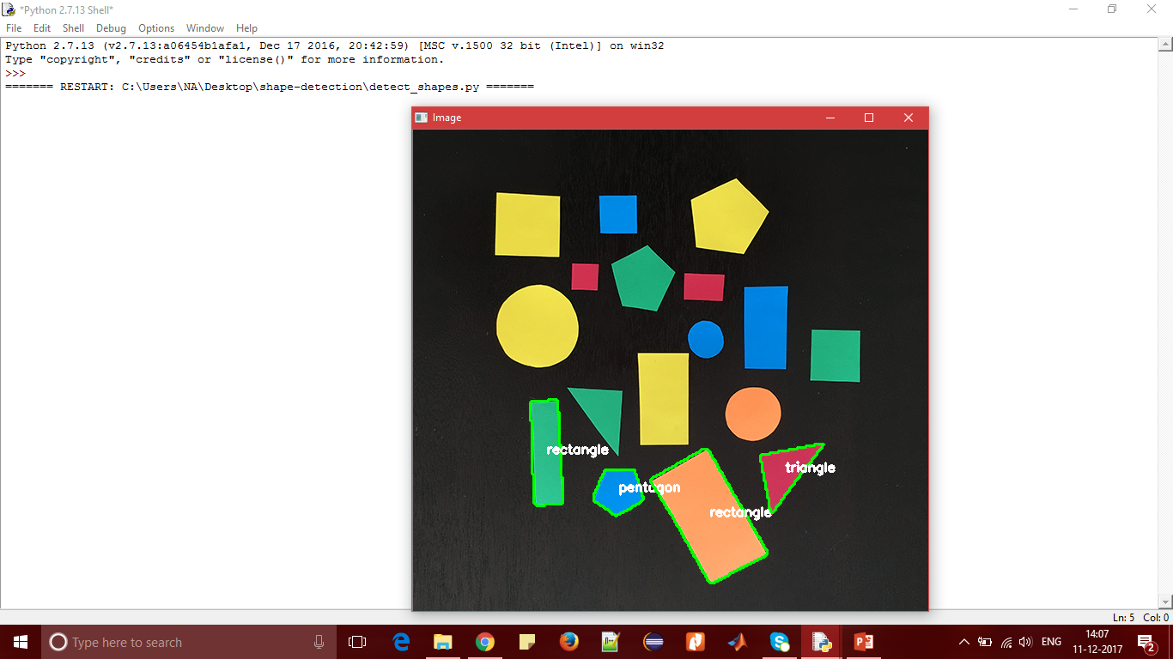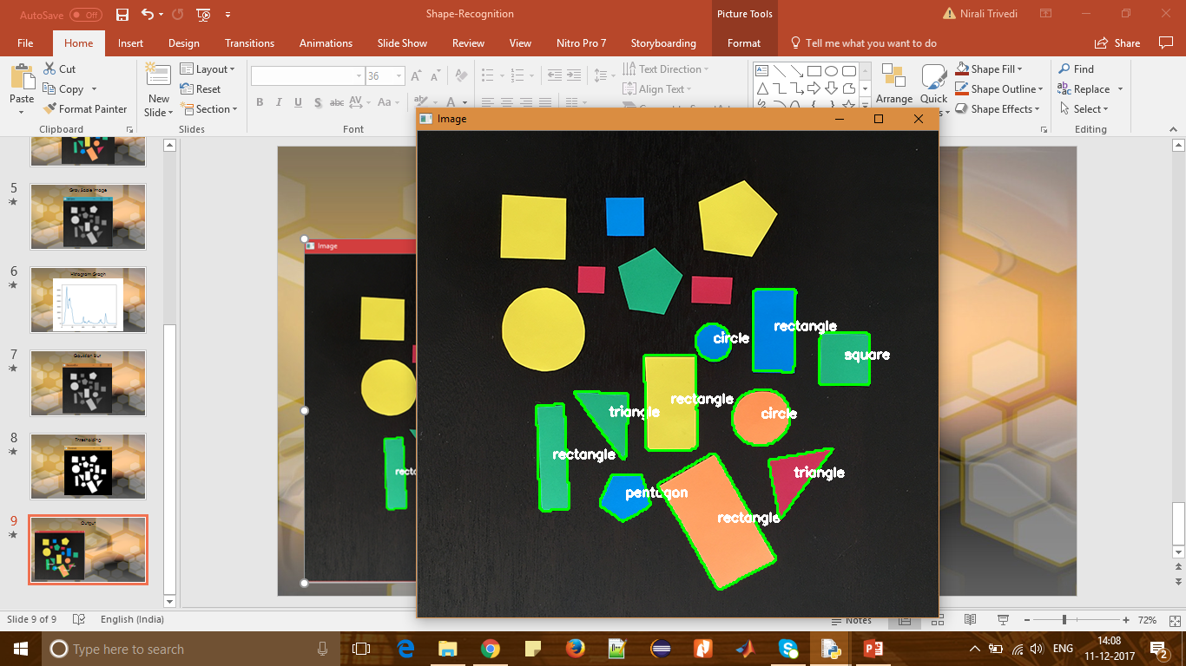

**Fig.7: Output 1 Fig.8: Output 2**

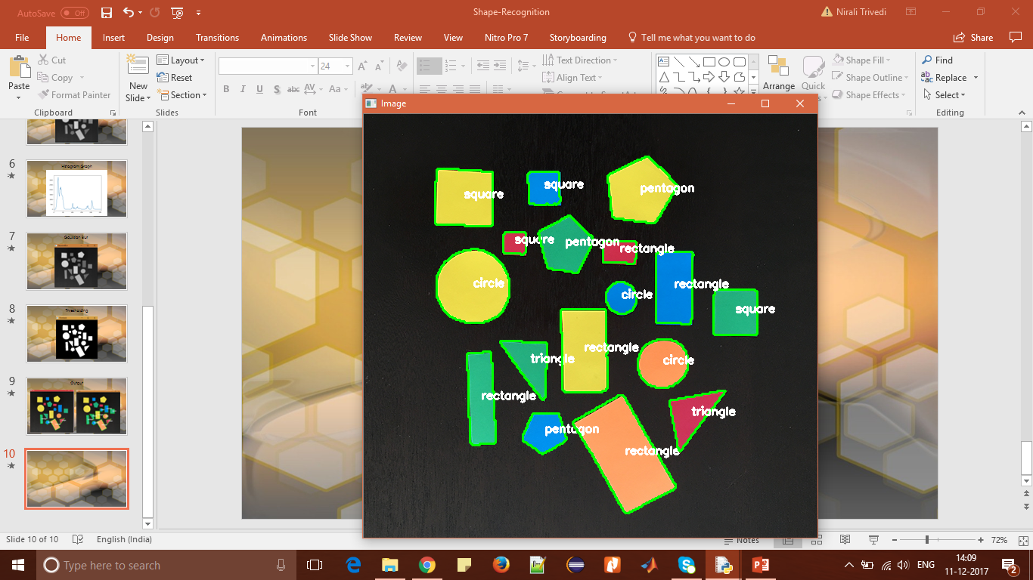

**Fig.9: Output 3**

1. **Conclusion**

The algorithm has good ability to detect most shapes in image and separate its prior to recognize. Its main objective is to differentiate basic shape such as circle, square and triangle in the given input image. Based on contour approximation, we examined the number of vertices each shape has. The vertex count, helps to accurately label each of the shapes.

1. **References**
2. https://www.pyimagesearch.com
3. http://opencv-python-tutroals.readthedocs.io
4. https://www.mathworks.com
5. https://www.wikipedia.org/
6. https://www.ijcsi.org/papers/IJCSI-10-6-1-162-166.pdf
7. http://esatjournals.net/ijret/2015v04/i05/IJRET20150405094.pdf